PMC Labor Cost Module

We have deployed the Labor Cost module in ERP-Administrator role. To access the module please refer to the navigation below.

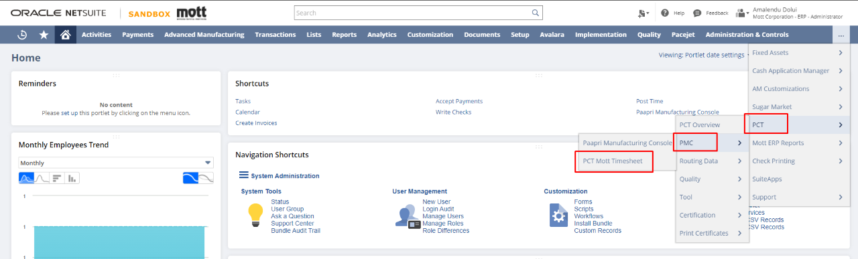

We have provided a badge ID (1111) to the employee named "Matthew Siok". We used this badge ID to login for testing purposes.
You can provide the badge ID in the 'Badge ID' field of the employee record.

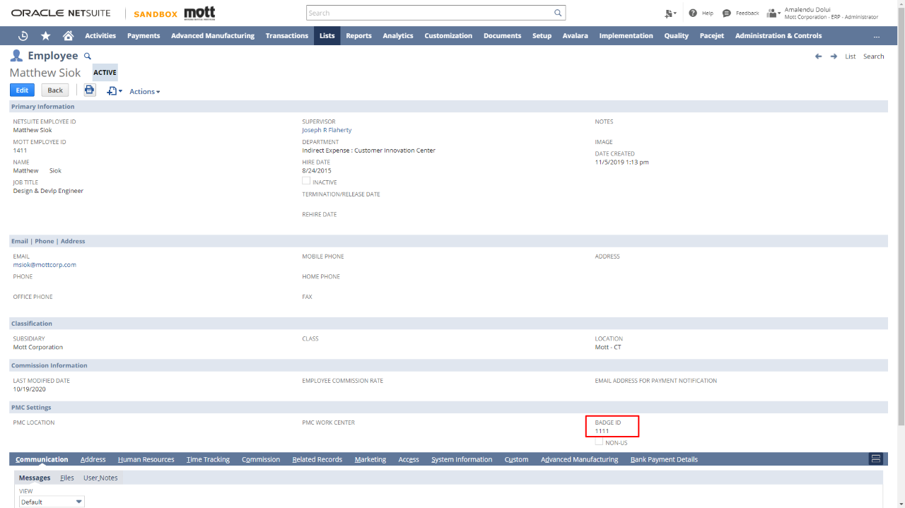

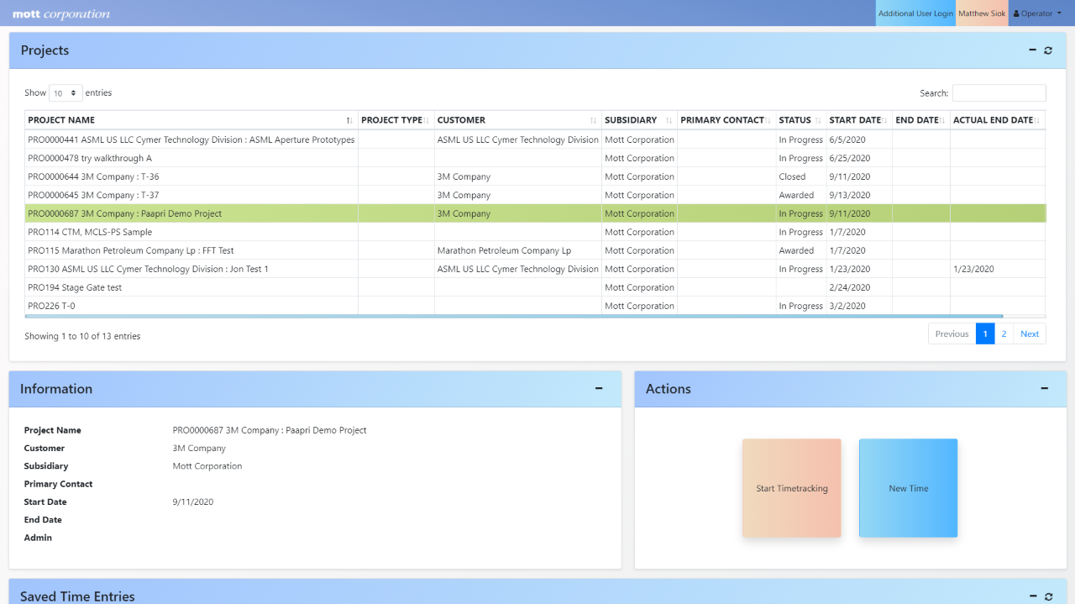

The Projects panel shows all the available and assigned projects to the particular user.

The Information panel shows all the related information for the selected Project from the Projects panel.

The Actions panel consists of three buttons, Start Time Tracking, Stop Time Tracking and Pause Time Tracking. These buttons are used to automatically record the duration for which the selected project was worked upon.

We have created a section (Saved Time Entries) that displays all the Time Entries that has been saved previously. Additionally, you can create the journal entries for the respective time entry you have selected.

The Post Time button will appear only for those time entries whose journal entry has not been posted.

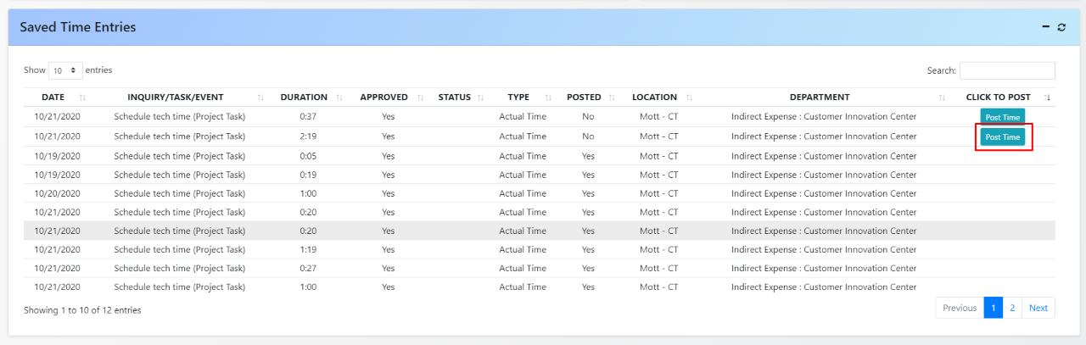

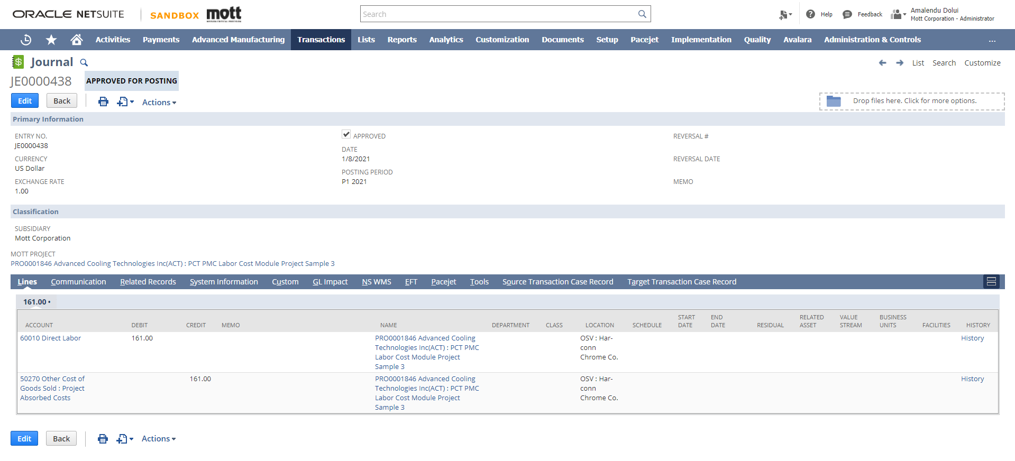
On clicking the Post Time button, journal entries will be created in Netsuite as shown below.

